St Katherine’s School

Travel Guide for
Students, Parents/Carers and Visitors

St Katherine’s School Ham Green
Bristol BS20 0HU

Tel: 01275 373737
Fax: 01275 372787

Email: school@stkaths.org.uk

Introduction

At St Katherine’s we have a high percentage of students travelling to school by car, coach or bus. This booklet provides details on how to get to school, however you decide to travel. Please travel as sustainably as you can.

As part of our School Travel Plan we consider all the current methods of transport to ensure:
- Student Safety
- Student Comfort
- Students healthy approach to travel
- A consideration of the local environmental impacts.

What it means for St Katherine’s
  - We work closely with the North Somerset Council School Travel team and our own School Travel Plan advisor.
  - We involve all stakeholders at the school, including School Council, students and parents to help develop and maintain the strategy.
  - We work with external partners such as transport providers, VOSA, the Traffic Commissioner and the local Police Community Support Officer (PSCO)
  - We look at the whole range of transport options and provisions for our staff and students.
  - We consider the environmental impact on our local community.

Travel information is also on the St Katherine’s School website: www.stkaths.org.uk in the ‘Transport and Travel’ section.

Walking to School
We encourage all our local students to walk whenever possible. Care should be taken on the local main roads and footpaths used.

Cycling to school
There are a number of safe cycling routes to St Katherines. Please use the secure cycle racks provided and lock up any cycles or equipment as the security of each student’s bike is their own responsibility. Visit www.betterbybike.info for more advice and details about cycle routes to and from St Katherine’s.

Secure cycle storage
There is a secure cycle storage facility for students and staff. Please note: students who bring their cycles to school do so at their own risk and school cannot take any responsibility for loss or damage. We recommend that any cycle equipment is insured and marked with the owner’s postcode. Users of these facilities must wear a helmet for their personal safety.

Walking and cycling zones
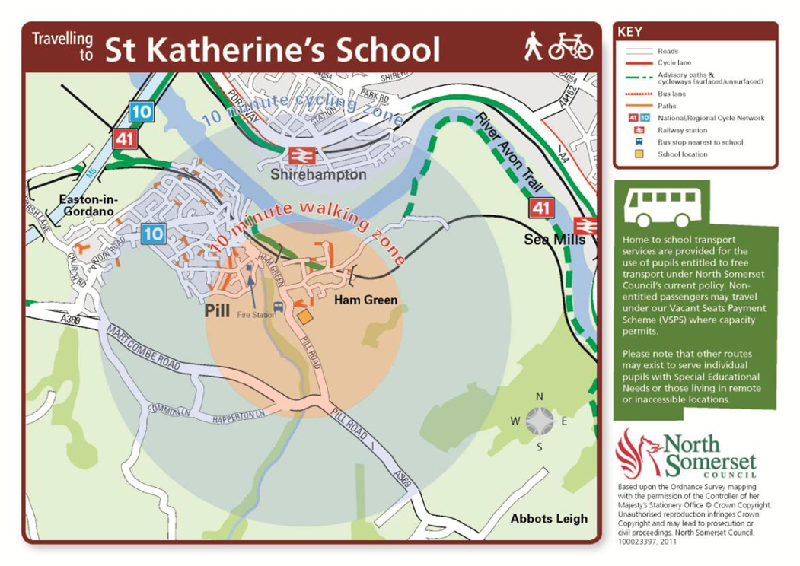
The map shows estimated 10 minutes walking and cycling distances to St Katherine’s.

Driving by car

From the M5 (Junction 19 M5)
Follow the road signposted to Bristol A369, continue along the Martcombe Road (A369) turn left, just after Haberfield Hill into Pill Road. St Katherine’s School is on the right approximately a quarter of a mile from the junction.

From Bristol
From Bristol city centre follow the signs for the M5 on the A369 leaving Bristol. Drive up Rownham Hill, through the traffic lights at the top and follow Abbots Leigh Road (A369) approximately 2 miles. Turn right into Pill Road just before Haberfield Hill. St Katherine’s School is on the right approximately a quarter of a mile from the junction.

Car sharing
As part of our School Travel Plan we try to discourage too many cars coming on site and encourage the use of public transport or cycling. However car sharing arrangements are an excellent option. Many parents have organised themselves into local groups and take it in turns to bring students to and from school. This can save a lot of time, fuel and congestion

Due to the Data Protection Act we cannot give out information about parents, however we have found that the students do most of the organising through friends in their tutors groups.

We would ask parents to make contact with each other and set up arrangements amongst themselves. You could contact other parents through the school Facebook page (St Katherine’s School). For other ideas and contacts please visit: www.2carshare.com

Smoking
St Katherine’s School operates a strict non-smoking policy which includes all grounds, buildings and cars on site.

Parking at St Katherine’s
We kindly ask that visitors park in the allocated parking bays and not in the areas designated for buses.
Please also avoid parking on the double yellow lines or near the gates as this obstructs access for coaches and deliveries. Users of car parks on the school site do so at their own risk. We will not accept liability for damage, loss or accident to any vehicles or contents.

Disabled parking
Disabled parking is available in the top car park, next to the English Faculty for Blue Badge holders.

Sixth Form Students driving to school
If a student has a valid licence to drive either a motorcycle or car and wishes to park in the car park, please ask permission from Mrs Woods in School Reception woodsg@skdrive.org Please note students’ motorcycles and cars should only be parked in the overflow car park.

Security
All visitors must sign in at the main school reception and provide car registration details. They will be given a visitor badge which must be worn at all times while on the school site and returned to visitor reception when signing out.

Movement on site
Please note there is a strict one way system as well as a 5 mph limit on site.

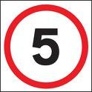
Travelling by bus

Home to School Transport Buses
Blue Iris Coaches (Tel. 01275 851121) provide transport for students entitled to free transport through the North Somerset Home to School Transport Scheme. Details of bus times and stops are provided below and in the bus pass pack given by North Somerset Council to eligible students. Please note: free transport does not apply to post-16 students.
 | Pick up | Return
Long Ashton Road/Theynes Croft | 8.05 | 15.54
Long Ashton Library/Weston Road | 8.10 | 15.50
St Katherine's School | 8.35 | 15.30

For more information about home to school transport contact:
Home to School Transport
North Somerset Council
Town Hall
Walliscote Grove Road
Weston-super-Mare
BS23 1UJ
Telephone: 01934 634715
Email: schooltransport@n-somerset.gov.uk
Web: www.n-somerset.gov.uk/hometoschooltransport

Public Transport

FirstGroup’s X3 and X4 buses travel between Bristol, Pill and Portishead and stop near St Katherine’s School. The X4 stops outside the school, the X3 stops 5-10 minutes’ walk away on the A369.
Full timetables are at: www.firstgroup.com/bristol-bath-and-west/timetables
First Bus Customer Services & Enquiries Tel: 0845 602 0156

You can also plan your journey on public transport by visiting Traveline South West: www.travelinesw.com

Eurocoaches (888A and 888B) and Carmel Coaches (X5) bus services
(Monday to Friday term time only)
Eurocoaches and Carmel Coaches operate these services as commercial regulated public bus routes. Although the school does not have a contractual agreement with these companies, we work closely with them and provide trained St Katherine’s Bus Monitors on their buses.
Please note: these buses stop at any recognised bus stops on the routes where students are waiting - students must put their hand out to ask the driver to stop. Most buses are single decker coaches. Please note the consumption of food or fizzy drinks is not permitted on any coaches or buses.

For more information about the 888A, 888B and X5 bus services please contact the operators directly (see timetable information below)

888A and 888B services

Operator details: Eurotaxis Tel: 01454 320022
Fare £4.50 return, £3.00 Single to be paid daily to the driver.

BUS STOPS & TIMES OF OPERATION - 888A
NUMBER | STOP LOCATION & NAME |  |  |  |  |  | AM | PM
1 | Gloucester Road - Horfield Sports Centre |  |  |  |  |  | 07:10 | 16:35
2 | Monks Park Avenue - Job Centre |  |  |  |  |  | 07:12 | 16:32
3 | Monks Park Avenue - Southmead Hospital |  |  |  |  |  | 07:15 | 16:29
4 | Southmead Road - Lidl Store |  |  |  |  |  | 07:17 | 16:27
5 | Southmead Road - Greenway Park |  |  |  |  |  | 07:19 | 16:25
6 | Southmead Road - Bear & Ruged Staff Pub |  |  |  |  |  | 07:22 | 16:22
7 | Southmead Road - Whiteleaze |  |  |  |  |  | 07:24 | 16:20
8 | Henleaze Road - Henleaze Lake |  |  |  |  |  | 07:25 | 16:19
9 | Henleaze Road - Eastfield Inn |  |  |  |  |  | 07:26 | 16:18
10 | Henleaze Road - Henley Grove |  |  |  |  |  | 07:28 | 16:16
11 | Westbury Road - Henleaze Gardens |  |  |  |  |  | 07:32 | 16:12
12 | Falcondale Road - Downs Road - this is a School Bus Only stop |  |  |  |  |  | 07:34 | 16:10
13 | Canford Lane - Sandyleaze |  |  |  |  |  | 07:38 | 16:06
14 | Canford Lane - Churchill Drive |  |  |  |  |  | 07:40 | 16:04
15 | Bell Barn Road -junc with Shirehampton Rd - no stop sited |  |  |  |  |  | 07:43 | 16:01
16 | Shirehampton Road - Sea Mills Square |  |  |  |  |  | 07:45 | 15:59
17 | Westbury Lane - junc with Shirehampton Rd / Iron Bridge |  |  |  |  |  | 07:48 | *15:52
18 | Westbury Lane - Southwood Drive |  |  |  |  |  | 07:49 | *15:53
19 | Westbury Lane - Aldercombe Road (Shops) |  |  |  |  |  | 07:50 | *15:54
20 | Sylvian Way - junc with Coombe Dale |  |  |  |  |  | 07:52 | *15:55
21 | Sylvian Way - Sunny Hill |  |  |  |  |  | 07:53 | *15:56
22 | Kings Weston Lane - Kings Weston House |  |  |  |  |  | 07:58 | 15:50
23 | Kings Weston Lane - Barrowmead Drive |  |  |  |  |  | 07:59 | 15:49
24 | Long Cross - junc with Kings Weston Lane - Roundabout |  |  |  |  |  | 08:00 | 15:48
25 | Long Cross - Badenham Grove |  |  |  |  |  | 08:01 | 15:47
26 | Long Cross - Roman Ruins |  |  |  |  |  | 08:02 | 15:46
27 | Kings Weston Avenue - Merrimans Road |  |  |  |  |  | 08:04 | 15:44
28 | Lower High Street - Hope & Anchor Pub |  |  |  |  |  | 08:07 | 15:41
29 | Avonmouth Road - Akeman Way |  |  |  |  |  | 08:08 | 15:40
30 | St Katherine’s School |  |  |  |  |  | 08:20 | 15:30
BUS STOPS & TIME OF OPERATION - 888B
NUMBER | STOP LOCATION & NAME |  |  |  |  |  | AM | PM
1 | Canford Lane - Westbury Village (W-bound am / E-bound pm) |  |  |  |  |  | 07:30 | 16:20
2 | Henbury Road - Falcon Close (return stop on Falcondale Rd) |  |  |  |  |  | 07:33 | 16:17
3 | Northover Road - Westover Road |  |  |  |  |  | 07:35 | 16:15
4 | Northover Road - Passage Road |  |  |  |  |  | 07:36 | 16:14
5 | Charlton Road - Burghill Road |  |  |  |  |  | 07:39 | 16:12
6 | Charlton Road - St Peters Hospice |  |  |  |  |  | 07:40 | 16:11
7 | Charlton Road - Standon Way |  |  |  |  |  | 07:42 | 16:09
8 | Charlton Road - Knole Lane |  |  |  |  |  | 07:45 | 16:07
9 | Knole Lane - St Joseph's Road |  |  |  |  |  | 07:46 | 16:06
10 | Knole Lane - Marlwood Drive |  |  |  |  |  | 07:47 | 16:05
11 | Crow Lane - Old Crow Pub / Roundabout |  |  |  |  |  | 07:49 | 16:03
12 | Crow Lane - Lay By |  |  |  |  |  | 07:50 | 16:02
13 | Henbury Road - Blaise Castle (pm extra stop on Hallen Rd) |  |  |  |  |  | 07:51 | 15:56
14 | Long Cross - De Clifford Road |  |  |  |  |  | 07:52 | 15:54
15 | Long Cross - Chapel Lane |  |  |  |  |  | 07:53 | 15:53
16 | Long Cross - St Bede's School |  |  |  |  |  | 07:54 | 15:52
17 | Long Cross - Lay By |  |  |  |  |  | 07:56 | 15:50
18 | Long Cross - junc with Kings Weston Lane - Roundabout |  |  |  |  |  | 07:58 | 15:48
19 | Long Cross - Badenham Grove |  |  |  |  |  | 08:00 | 15:47
20 | Long Cross - Roman Ruins |  |  |  |  |  | 08:02 | 15:46
21 | Kings Weston Avenue - Merrimans Road |  |  |  |  |  | 08:04 | 15:44
22 | Lower High Street - Hope & Anchor Pub |  |  |  |  |  | 08:07 | 15:41
23 | Avonmouth Road - Akeman Way |  |  |  |  |  | 08:08 | 15:40
24 | St Katherine’s School |  |  |  |  |  | 08:20 | 15:30

X5 service
Serving Wells Road, Broad Walk, Redcatch Road, St Johns Lane, North Street, East Street, Ashton Gate, Sea Mills, Shirehampton, Avonmouth.

X5 – stops at all stops on route | Pick up | Return
Wells Road, The Bush | 7:35 | 16:15
Broadwalk shops |  | 16:10
St John’s Lane, Wedmore Vale | 7:38 | 16:05
Bedminster, opposite Post Office | 7:45
North Street (Hen and Chicken) | 7:50 | 16:02
Ashton Gate |  | 16:00
Sea Mills, Roman Way | 8:10 | 15:55
Shirehampton Station | 8:15 | 15:47
Avonmouth roundabout | 8:24
Avonmouth , Portview Road |  | 15:44
St Katherine’s School | 8:35 | 15:30
Daily Fares (to be paid to driver)
£3.50 single or £4.50 return; 10 ticket package £22.00 offering flexible travel;
weekly pass: £20.00 to be paid to the driver

Termly Pass (based on six terms per year): £115 per term.
For termly passes please contact the company directly.

Operator details:
CARMEL COACHES Tel: 01275 859123, www.carmelcoaches.co.uk

Code of Conduct for Bus and Coach Users
Purpose
- To ensure the interests of all Students’ Health and Safety are met.
- To ensure that all Students have an enjoyable, stress free journey to and from school.
- To uphold the reputation of St Katherine’s School.
- To encourage good behaviour, respect and self-discipline amongst all students.

Code of Conduct
- To be smartly dressed in school uniform or appropriate attire for Sixth Form students.
- No consumption of food, snacks or fizzy drinks (still drinks and water allowed)
- No smoking or consumption of alcohol or dropping litter.
- No use of bad language, swearing or language of an inappropriate or aggressive nature.
- Have your ticket available or money ready to purchase a ticket, you will not be allowed on the bus without a ticket or payment.
- Be polite and courteous to each other, drivers and members of the public.
- Under no circumstances must tickets be copied or forged.

- Wait for the bus or coach in an orderly queue without any pushing.
- Allow members of the public to pass and/or walk by.
- Embark in a calm and safe manner.
- Disembark in an orderly and safe manner.
- Find a seat and remain seated at all times.
- Under no circumstances should you leave the bus before your usual bus stop if you have a problem report it to your Bus Monitor.
- In the event of a bus not arriving/stopping for the school-bound journey, please call school immediately – do not start walking.

- Do not do anything that might endanger you, other students or the driver.
- Remain seated until the bus has stopped at your bus stop.
- Do not call out to other students or distract the driver.
- Obey the instructions of the School Bus Monitors.
- No consumption of food, snacks or fizzy drinks (still drinks and water allowed)
- Place any litter or chewing gum in bins or bags provided or take it home.
- In the event of an emergency only leave the bus if requested to do so by the driver or Bus Monitor, wait for replacement transport do not start walking.

Bus Monitors
Bus Monitors are appointed and trained by the school to ensure the Code of Conduct is observed and to report any issues that may arise back to school for the school to deal with. Students who may have concerns when travelling on the bus should approach their Bus Monitor.

Disciplinary Action
Any reported poor behaviour or failure to observe the Code of Conduct for Buses will be dealt with as a disciplinary issue by school. The Bus Operators have the right to ban students from their bus service/s.

