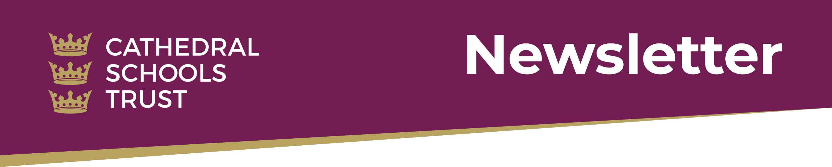

Dear Parents and Carers,

2019 has been another very busy year for Cathedral Schools Trust with many exciting developments. We started the year by welcoming St Katherine’s School in Pill to the trust, Stoke Park Primary School joined in June and we opened Trinity Academy in September. As our organisation has grown in scale, we have been able to increase opportunities for collaboration, challenge and support.
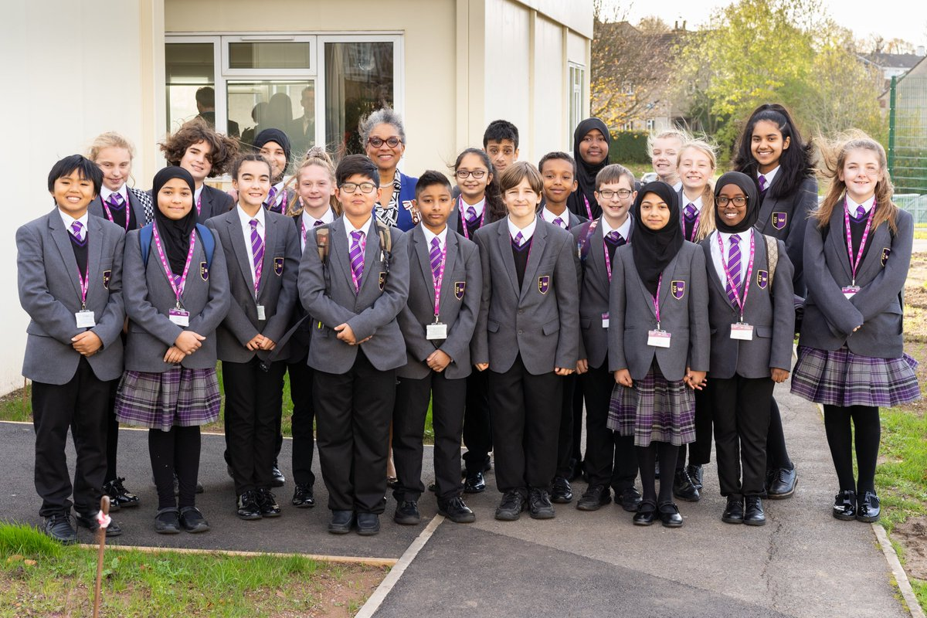
After several years of hard work behind the scenes, the opening of Trinity Academy was a particular highlight of 2019. The school will provide much needed secondary school places in the north of the city and, we believe, will have a transformative effect on the local community. The first 120 children have settled in extremely well and made a very positive start. In November we held a ‘ground-breaking’ ceremony and it was exciting to hear the student’s ideas on how their new community will evolve in the future. Trinity Academy is currently in temporary accommodation and sharing a site with Stoke Park Primary. Construction work has now begun on the new building and it won’t be long before we start to see it emerge. Part of our vision for the new school is to create a performing arts space for Lockleaze and the wider community. To help us achieve this goal, we have launched an ambitious fundraising campaign. Please click here to find out more.

At the start of this academic year we developed a new team of Lead Practitioners: outstanding teachers who are supporting colleagues within their own and other schools to improve their teaching practice. The lead practitioners have led staff training, delivered demonstration lessons and developed action research projects in order to ensure your children get the best possible education we can offer.

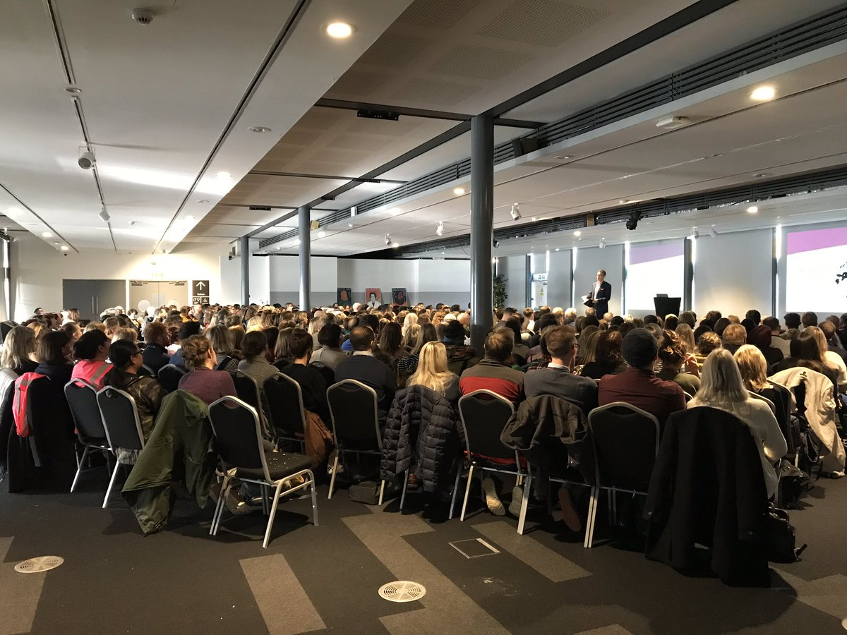
Throughout the year our staff have continued to network by visiting each other’s schools, attending training sessions, and working on joint projects together. We have run a range of professional development opportunities, including accredited leadership development programmes and programmes for newly qualified staff. Perhaps the highlight of our collaborative work was our joint inset day earlier this term when all 350 staff met for a range of workshops and training activities. The spirit of collaboration was palpable and it was great to see colleagues from across all seven schools networking, sharing ideas and learning from one another.

There have also been lots of opportunities for our children to get together for sporting and artistic events. We have exciting plans for enrichment experiences in 2020, including a musical event with the South African choir Project Zulu, a joint ‘Earth Week’ and conference on sustainability for pupils from all seven schools, an art exhibition and our annual trust music concert in Bristol Cathedral.

We remain committed to using music as a way of building community and raising expectations. Andi Nichols joined in September as our new head of specialism to promote music across the trust. He will be working closely with each school’s head of music to find ways to improve music provision in all seven schools. It has been nice this week to see pupils from BCCS supporting St Katherine’s musicians in the orchestra for their production of ‘Miss Saigon’.

Over the past two weeks, I have been busy attending nativities, carol services and Christmas concerts in all seven schools. It has been a real pleasure to see young people of all ages performing with such confidence. My thanks to all the staff who give the children these wonderful opportunities and for the dedication and commitment they show.

I wish you and your family a very merry Christmas.

Best wishes,
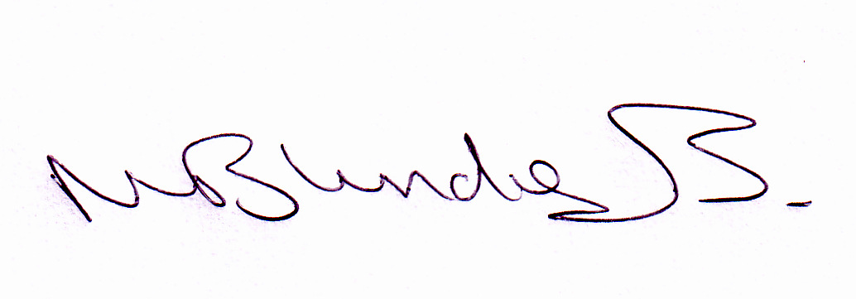

Neil Blundell

